Meeting Report
EASI Forum
Dresden, September 4th, 2009

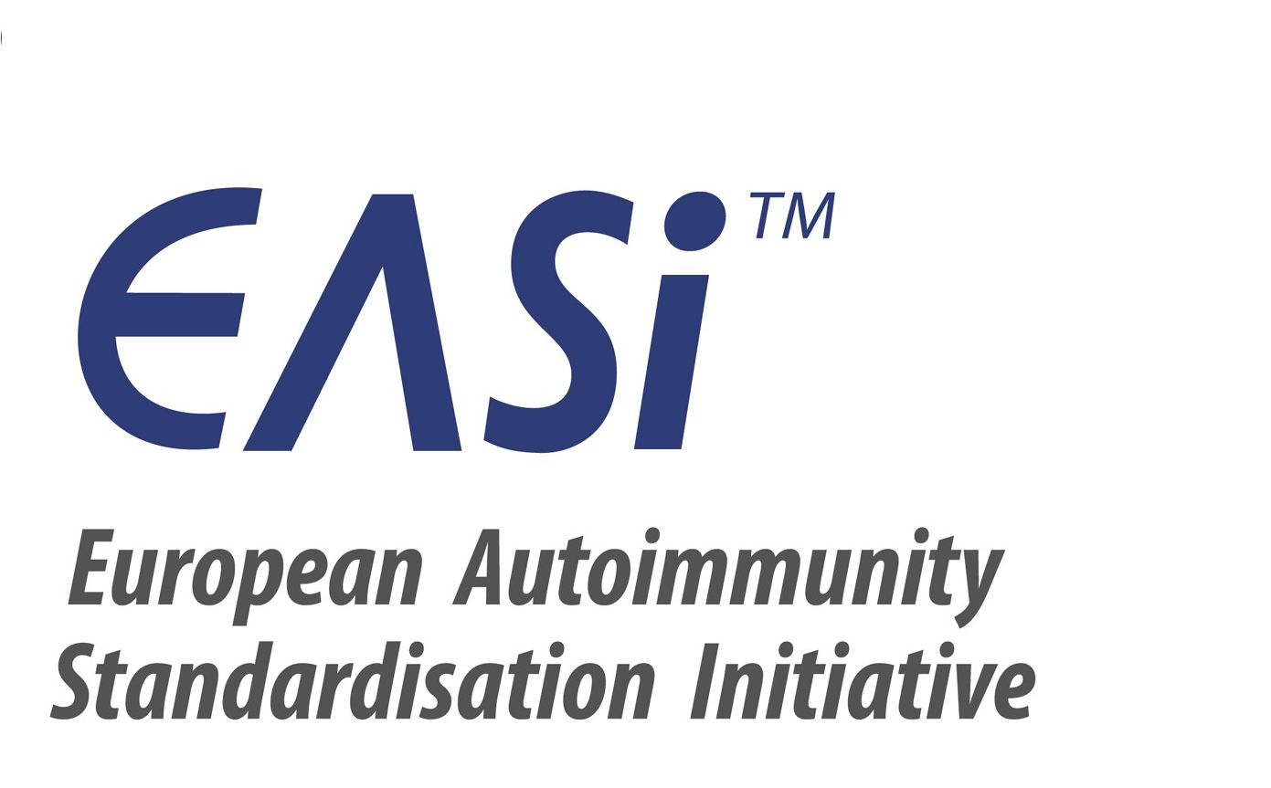

Participants: Aresio Plaza (ES), Ulrich Sack (D), Xavier Bossuyt (B), Lucile Musset (F), Nicole Fabien (F), Walter Fierz (CH), Markku Viander (FIN), Manfred Herold (A), Antonella Radice (I), Pier-Luigi Meroni (I), João Pedro Ramos (PT), Jan Damoiseaux (NL), Yehuda Shoenfeld (Isr), Nancy Agmon (Isr), Elias Toubi (Isr)
Phadia: Karin Walcher (A), Gerhard Hufnagel (CH), Juan Jimenez (E), Carmen Andalucia (ES), Gerben Zuiderveld (NL), Udo Schlosser (D), Kai Wiebke Steffen (D), Paulo Dias (PT), Teresa Araujo (PT)
Protocol: Michael Haass (D)

Discussion Topics and Decisions

EASI Projects

- Booklet for Family Doctors
The preparation of the booklet is progressing.
The goal is still to have it ready to be distributed for the International Congress on Autoimmunity in Ljubljana, May 2010.
Eight of the chapters are delivered so far and accepted by the editors:
  - SLE (Solis, Witte, Hiepe, Messer, Chyderiotis, Musset, Pham, Fabien, Olsson, Cervera; Germany, France, Spain) (ü)
  - Sjögren’s Syndrome (Witte, Meroni; Germany, Italy) (ü)
  - ANCA-associated vasculitis (Holle, Csernok, Herlyn, Wiik, Gross; Germany Denmark) (ü)
  - Non-ANCA-associated vasculitis (Holle, Csernok, Herlyn, Wiik, Gross; Germany Denmark) (ü)
  - Myositis overlap syndromes (Vencovsky, Lunderg, Kallenberg, Mierau; Czech Republic, Sweden, The Netherlands, Germany) (ü)
  - Addison disease (de Carvalho, Pereira, Shoenfeld (Brasil, Israel) (ü)
  - Guillain-Barré Syndrome (Untermann, Chapmann, Shoenfeld; Israel) (ü)
  - Myasthenia Gravis (Damoiseaux, Fontana, Schneider, Blaes, de Baets; The Netherlands, Germany) (ü)
Two chapters are delivered to the editors but need to be completed:
  - Polymyositis and dermatomyositis (Kallenberg, Benveniste, Vencovsky, Lundberg, Grau, Genth, Mierau; The Netherlands, France, Sweden, Spain, Germany)
(Harmonize the institute addresses)
  - Coeliac disease (Henker, Chyderiotis, Musset, Pham, Fabien, Olsson; Germany, France)
(Refer to the references in the text with numbers)
Chapters still in preparation:
  - APS (Khamashta, van Landenberg, Hughes; UK)
  - Discoid lupus, Subacute cutaneous lupus, Neonatal lupus / congenital heartblock (Messer; Germany)
  - UCTD (Hiepe; Germany)
  - Pemphigus vulgaris, Pemphigus foliaceus (Messer; Germany)
  - Bullous Pemphigus (Messer, Kromminga; Germany)
  - RA, Felty’s Syndrome, Psoriasis Arthritis, Juvenile Rheumatoid Arthritis, Lyme Arthristis (Herold, Wiik, Steiner, Sack, Borte; Austria, Germany)
  - Autoimmune Hepatitis, PBC, Primary Sclerosing Cholangitis (Klein; Germany)
  - Cryoglobulinemia (Cacoub; France)
No response from the authors for:
  - Inflammatory Bowel Diseases (Folwaczny (Germany),
  - Autoimmune Neuropathies, Multiple Sclerosis, Paraneoplastic Autoimmune Diseases (Blaes / Schneider, Germany)
One author refused to write chapter:
  - Autoimmune Thrombocytopenia purpura (Godeau, France)
After the discussion in the Forum new authors were found for:
  - Autoimmune Thrombocytopenia purpura (E. Toubi, Israel)
  - Inflammatory Bowel Diseases (X. Bossuyt, Belgium, Polanco, Spain)
  - Myocarditis (Y. Shoenfeld, Israel)
  - Polychondritis (M. Herold)
  - Collitis ulcerosa (X. Bossuyt, Belgium, Polanco, Spain)
  - Morbus Crohn (X. Bossuyt, Belgium, Polanco, Spain)
  - Irritabl Bowel Syndrome (X. Bossuyt, Belgium, Polanco, Spain)
  - Polyglandular autoimmunity syndromes: Review (Rema, Dias; Portugal)
  - Autoimmune Thyroid Diseases (Rema, Dias; Portugal)
  - Pernicious anemia (Silva, Dias; Portugal)
  - Fibromyalgia (Y. Shoenfeld, Israel; XX, DenmarK)
No authors volunteered up to now for:
  - Type 1 diabetes
  - Autoimmune gastritis

To keep the time line, it is important to prepare the new chapters as soon as possible and submit the manuscripts not later than end of November 2009.
The authors should send the chapters of the booklet to Michael Haass (michael.haass@phadia.com), who will prorate them to the EASI Core Team members for final reviewing.
Please follow the Instructions for the authors and consider the example chapter about Myasthenia Gravis (see attachment).
All authors are requested to provide a written statement to Michael Haass that the pictures that are used in their manuscripts are owned by the authors and that EASI is allowed to use them in the Family Doctors Booklet.
Please, contact your personal network to identify colleagues who are willing to support EASI in writing one of the missing chapters of the Family Doctors Booklet.

- EASI Website
The EASI Website was presented.
The link to the EASI Network websites is www.easi-network.com.
Some EASI teams started already to fill the Website with their national team activities and achievements.
All EASI Teams are appealed for taking the time to fill the national sites.
For questions related to the EASI websites please contact the main administrators Michael Haass or Nina Olschowka or the Phadia coordinators of the EASI teams who are the local administrators.
All EASI team members are asked to send information about
- Congresses (what, where, when, link)
- Comments about congresses held (organizer of the congress should be asked to present a short summary about the congress with the most important results and messages)
- Pictures
- Comments about books which were recently published (summary, recommendation, content list, cover picture)
- Actual publications from the area of autoimmunity
to Nina Olschowka published the information on the EASI website as the EASI Paper of the month on the website).

- Comparative evaluation of automated methods for autoantibodies testing as a multicentre study in Europe
The multicentre study about the performance of the different automated methods used for autoantibody testing in comparison with gold standard methods is planned in cooperation with the International Society of Clinical Chemistry to evaluate the performance of different assay systems in Europe.
The study should be divided into
- a prospective study with patients showing an undefined picture of CTD. These patients should be randomly selected by the clinicians and followed over a period of 2-3 years with repeated blood taking. Criteria that should be used for the diagnosis are those for UCTD.
- a retrospective clinical study including
  - clinically well defined samples provided by different centers of the different EASI groups (2 samples from each centre of a volume of at least 3 ml). The patients should show the full blown picture of the disease
  - control samples as disease samples from non autoimmune diseases with the same clinical background information and at least 3 ml volume
  - healthy individuals and
  - blood donors.
All samples will be collected by the participating clinicians and lab specialists, send to Pierre Youinou in Brest, who will code and aliquot the samples. He will furthermore send the samples blinded to the manufacturers who will analyze the antibody content and level with their instruments and methods.
Manufacturers who will participate in the study will be contacted by the EASI Core Group members and instructed how to participate in the study. They should pay a fee for the participation in the study, run the samples on their test systems and provide the data to the EASI Core Group for evaluation of the results.
The following technologies should be included:
- Immuno-Precipitation
- IFA
- FARR RIA
- Multiplex Technologies
- Automated EIA technologies
Next Steps:
- Pier-Luigi Meroni will send
  - the description of the study design
  - and the criteria for the collection of clinical samples
to Michael Haass, who will distribute it to the EASI members.
- All EASI members are welcome to deliver comments to Pier-Luigi Meroni.
- All EASI members who are interested in contributing samples to the study should get in touch with Pier-Luigi Meroni or Michael Haass.
- The letter of approach of the manufacturers is designed already.

- Collection of algorithms for antibodies testing in systemic autoimmune diseases
The algorithms used for autoantibodies testing in Europe are manifold. Even within the counties there are various standards established in the different laboratories. To get an overview, the EASI teams of the network are preparing to collect information about the various algorithms in their countries and identify the most prominent and best version.
To simplify the data collection, a questionnaire of the national foundation for quality assessment in clinical laboratories (SKML = Stichting Kwaliteitsbewaking Medische Laboratoriumdiagnostiek) can be used that has been applied successfully to the Dutch Autoimmunity Community.
To enable a finals analysis of the data on a national and European level, the questions of the questionnaire should not be modified. To shorten the questionnaire, the number of questions in the questionnaire can be reduced.
If results from the evaluation will be published, the inventors of the questionnaire should be recognized: and credit should be given to Jan Damoiseaux, Dutch EASI and Liesbeth Bakker, SKML..

- Presentation of the national EASI team activities:
To get an overview what is ongoing in the different EASI teams, the coordinators presented their national team activities and achievements.
The files of the teams that presented their results are attached to this protocol.

- EASI Conference at the International Congress on Autoimmunity in Ljubljana:
We need to improve the “quality” of the EASI Conference. Therefore, it is required to introduce some rules for the coordinators’ presentations:
- Each presentation in 5 min (2 min for questions)
- Presentation of RESULTS of the active projects; e.g. data about:
  - Study results that demonstrate the clinical value of existing or new markers, c
  - comparative evaluations between different methods or assays,
  - analysis of new technologies
  - results of country specific investigations
(e.g. algorithms for the diagnostics of CTD)
IMPORTANT for all EASI presentations is: Highlight the importance of the findings for the improvement of Autoimmunity diagnostics or how it can help EASI to fulfill the goals EASI want to achieve.
Please, submit a short abstract to the organizers as requested (deadline December 07, 2009)

- Next EASI Forum Meeting
The next EASI Forum Meeting will be held attached to the International Congress on Autoimmunity in Ljubljana, May 2010.

SUMMARY TO DO’s
- EASI Family Doctors’ Booklet
  - Keep the time line for the submission of the manuscripts for the Family Doctors Booklet.
Prepare the chapters according to the instructions and submit them to Michael Haass (michael.haass@phadia.com) not later than November 29th, 2009.
  - Please provide a written statement to Michael Haass that the pictures that are used in your manuscripts are owned by the authors and that EASI is allowed to use them in the Family Doctors Booklet.
  - Please, contact your personal network to identify colleagues who are willing to support EASI in writing one of the missing chapters of the Family Doctors Booklet.
- EASI Website
  - Please take the time to fill the national EASI Websites to make this EASI Internet presentation as attractive as possible.
  - Please provide Nina Olschowka (nina.olschowka@phadia.com) with information about congresses, books which were recently published, actual publications from the area of autoimmunity pictures and send her pictures that can be used on the websites.
- EASI Multicenter Study
  - Please deliver comments about the design of the multicentre study to Pier-Luigi Meroni.
  - If you are interested in contributing samples to the study, please, get in touch with Pier-Luigi Meroni or Michael Haass.
- National Diagnostic Algorithms
  - Please discuss the SKML questionnaire in your local teams and prepare a version that you can use to identify the algorithms used in your country for AI diagnostics.
  - Please, do not modify the questions. If the questionnaire is to long just reduce the number of questions.
- EASI Conference in Ljubljana
  - Please prepare your presentation for the next EASI Conference in Ljubljana according to the new guidelines.
  - Submit your abstracts to the organizers not later than December 07, 2009.
- Next EASI Forum
  - Please, block your agenda for participation in the next International Congress on Autoimmunity.

Freiburg, November 9th, 2009
Michael Haass

Attachments:
- List of authors for the EASI Family Doctors Booklet
- Instructions for the Authors
- Letter to the authors
- Model Chapter about Myasthenia Gravis

