Minutes
EASI Forum
Granada, May 11, 2012

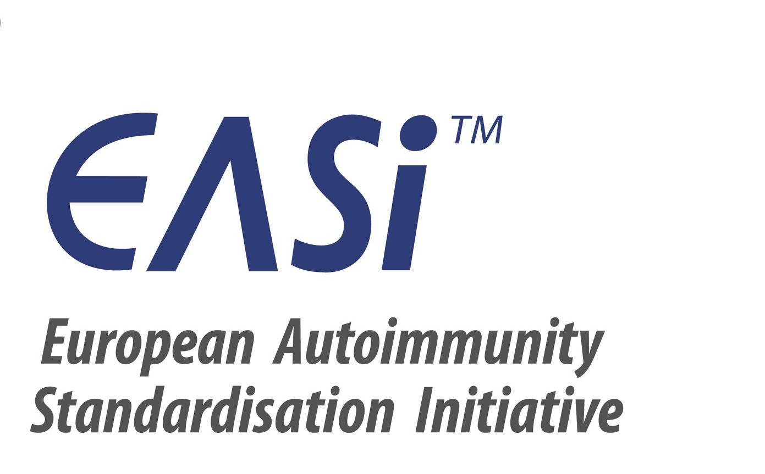

Participants: Yehuda Shoenfeld (IL), Nancy Agmon-Levin (IL), Laura Bianchi (I), Xavier Bossuyt (BE), Ricard Cervera (ES), Aresio Plaza López (ES), Jan Damoiseaux (NL), Carlos Dias (PT), Kerstin Elvin (SE), Catharina Eriksson (SE), Nicole Fabien (FR), Andrea Griesmacher (AT), Arno Hänninen (FIN), Manfred Herold (AT), Maria José Rego de Sousa (PT), Cees Kallenberg (NL), Munther Khamashta (UK), Pier-Luigi Meroni (IT), Lucile Musset (FR), Nils-Oliver Olsson (FR), Antonella Radice (IT), Johan Rönnelid (SE), Ulrich Sack (DE), Günter Steiner (AT), Olli Vianio (FI), Markku Viander (FI),
Thermo Fisher Scientific: Eckart Mummert (DE), Nina Olschowka (DE)
Carmen Andalucia (ES), Teresa Araujo (PT), Vincent Bouldoir (FR), Gabi Gross (DE), Michael Haass (DE), Lilian Larsson (SE), Emilie LeFloch (FR), Cesare Paparella (IT), Udo Schlosser (DE), Monika Snor (AT), Sune Sved (FI), Gerben Zuiderveld (NL),
Minutes: Nina Olschowka

Discussion Topics and Decisions

- EASI recommendations for standardization of ANA tests
The recommendations for ANA tests will be made in collaboration with IUIS (International Union of Immunological Societies) – therefore it will be EASI and IUIS recommendations.
Nancy Agmon-Levin from Israel showed the recommendations which have now a very high degree of agreement (Delphi Score) from all groups. 31 recommendations (based on 4 algorithms) were put together and sent out to the different national EASI groups. 17 of 31 recommendations were graded with Full to Major agreement, 14 recommendations were discussed and were adapted accordingly (presentation and recommendations attached to this summary).
The recommendation on methods for anti-dsDNA testing got the lowest, but still an acceptable degree of agreement. The group discusses that the methods of dsDNA testing should be explained in the addendum of the recommendations in terms of “what does a positive result mean, how to interpret inconsistencies, including pros and cons of these methods and respective references.
All in all the recommendations assume some knowledge on the side of the physician and some ability to interpret lab results.
It is mandatory that different methods are reported.
Further steps:
Nancy Agmon-Levin and Jan Damoiseaux will write a paper and send it to the national EASI groups and to the IUIS for an agreement.
Monitoring of success of the recommendations: questionnaire shall be repeated in some years, if possible with exactly the same questions. Change of algorithms?

- Booklet for family doctors: The Practice Guide to Autoimmune Diseases
10,000 copies of the EASI booklet for family doctors are printed, app. 2000 are distributed on the 8th International Congress on Autoimmunity in Granada. Citation:
The Practice Guide to Autoimmune Diseases
Y.Shoenfeld and P.-L. Meroni (editors), Pabst Science Publishers, Lengerich, Berlin, Riga, Rom, Viernheim, Wien, Zagreb, 2012
ISBN 978-3-89967-770-6
The book has 330 pages and includes 35 chapters, written by 60 authors. All EASI groups will get 50 copies each for free for local distribution. Authors can get additional copies by sending an e-mail to
nina.olschowka@thermofisher.com

Further possible distribution
- To congresses of general practitioners (cost issue)
- To associations of general practitioners (which format?)
It is important to increase interest and create awareness that the book is available. For example: book reviews in journals. In each country it should be announced (country-specific). The local EASI groups are asked to come up with suggestions for further distribution in their respective country. Cees Kallenberg agrees in writing a review which could be used in different journals and on websites for general practitioners.
Additionally, the book should be available online. Nina will try to get a pdf for the EASI page and for other pages.
If the book is further distributed as hardcopy the costs will be 5 Euro per copy, available via the subsidiaries of Thermo Fisher Scientific in the different countries.

- New Projects
Yehuda proposes that EASI writes a book on the use of markers for autoimmune diseases. Therefore, all clinically relevant autoantibodies should be included. The basic idea is a book which helps the physician to better understand and to interpret laboratory results (both IFA and EIA) correctly.
Alternatively, a website (share via EASI) could be installed, but not too complicated! A practicable and simplified interpretation tool for physicians to understand the results from the lab.

Next EASI Forum Meeting
The next two EASI Forum meetings will be held attached to the Dresden Congress on Autoantibodies in autumn 2013 and on the 9th International Congress on Autoimmunity in Nice, May 2014.
Another option is to meet at the 15th International Congress on Immunology in Milan in August 2013, if not too close to the Dresden congress and if regarded necessary.

Attachments:
- Presentation of Nancy Agmon-Levin “The EASI-recommendations for standardization of ANA”

