Meeting Report
EASI Forum
Ljubljana, May 7th, 2010

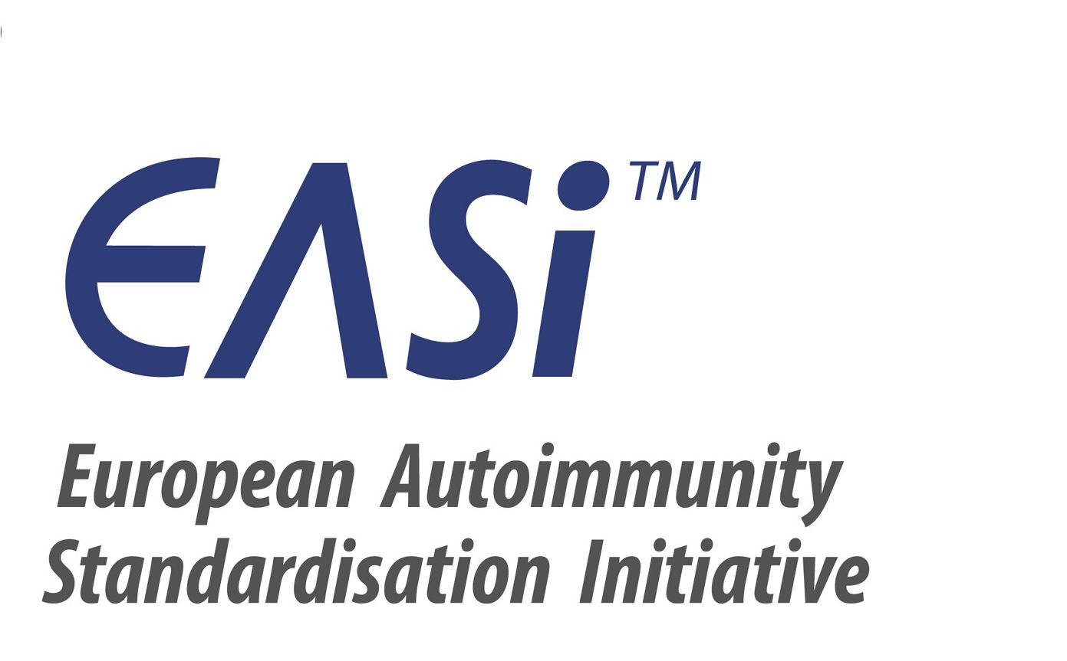

Participants: Aresio Plaza (ES), Ulrich Sack (D), Xavier Bossuyt (B), Lucile Musset (F), Nicole Fabien (F), Markku Viander (FIN), Antonella Radice (I), Pier-Luigi Meroni (I), Carlos Dias (PT), João Pedro Ramos (PT), Kees Kallenberg (NL),Jan Damoiseaux (NL), Allan Wiik (DK), Yehuda Shoenfeld (Isr), Nancy Agmon-Levin (Isr)
Phadia: Karin Walcher (A), Gerhard Hufnagel (CH), Walter Ineichen (CH), Juan Jimenez (E), Carmen Andalucia (ES), Gerben Zuiderveld (NL), Ief Mattheus (B), Claire Chupin (F), Emmanuel Claudel (F), Colet Mavier (F), Gianni Sordi (I), Udo Schlosser (D), Kai Wiebke Steffen (D), Paulo Dias (PT), Teresa Araujo (PT), Sune Sved (FIN), Jari Suori (FIN), Motti Schori (Isr.), Felix Gastager (AT), Nina Olschowka (D), Michael Haass (D)
Protocol: Michael Haass (D)

Discussion Topics and Decisions

Agenda

Status of the EASI Projects

EASI Family Doctors Booklet (Status)

EASI Website (Status)

EASI surveys (Laboratory survey based on the Dutch Questionnaire; Clinical Questionnaire)

Results of the national EASI Team activities

Positioning paper of the EASI Steering Group together with the EASI Forum how CTD Diagnosis should be supported in Europe

Next EASI Forum meeting

- Status of the EASI Projects

  - Booklet for Family Doctors
Unfortunately, the goal to have it ready to be distributed for the International Congress on Autoimmunity in Ljubljana, May 2010 could not be achieved.

The current status of the preparation is:
- Eight of the chapters are delivered so far and accepted by the editors.
- Two chapters are delivered to the editors but need to be completed:
  - Polymyositis and dermatomyositis (Kallenberg, Benveniste, Vencovsky, Lundberg, Grau, Genth, Mierau; The Netherlands, France, Sweden, Spain, Germany)
(Harmonize the institute addresses)
  - Coeliac disease (Henker, Chyderiotis, Musset, Pham, Fabien, Olsson; Germany, France)
(Refer to the references in the text with numbers)
- Chapters still in preparation:
  - APS (Khamashta, van Landenberg, Hughes; UK)
  - Discoid lupus, Subacute cutaneous lupus, Neonatal lupus / congenital heartblock (Messer; Germany)
  - UCTD (Hiepe; Germany)
  - Pemphigus vulgaris, Pemphigus foliaceus (Messer; Germany)
  - Bullous Pemphigus (Messer, Kromminga; Germany)
  - RA, Felty’s Syndrome, Psoriasis Arthritis, Juvenile Rheumatoid Arthritis, Lyme Arthristis (Herold, Wiik, Steiner, Sack, Borte; Austria, Germany)
  - Autoimmune Hepatitis, PBC, Primary Sclerosing Cholangitis (Klein; Germany)
- No response at all yet for:
  - Autoimmune Neuropathies, Multiple Sclerosis, Paraneoplastic Autoimmune Diseases (Blaes / Schneider, Germany)
- The following chapters from the authors who volunteered in Dresden are still pending:
  - Autoimmune Thrombocytopenia purpura (E. Toubi, Israel)
  - Myocarditis (Y. Shoenfeld, Israel)
  - Polychondritis (M. Herold)
  - Polyglandular autoimmunity syndromes: Review (Rema, Dias; Portugal)
  - Autoimmune Thyroid Diseases (Rema, Dias; Portugal)
  - Pernicious anemia (Silva, Dias; Portugal)
  - Fibromyalgia (Y. Shoenfeld, Israel; XX, DenmarK)
- No authors volunteered up to now for:
  - Type 1 diabetes
  - Autoimmune gastritis

Please, prepare the chapters or get in touch with the authors and strive that the missing chapters will be sent to Michael Haass (michael.haass@phadia.com) within the next few months.
Deadline: October 1st, 2010
Please, follow the Instructions for Authors and consider the example chapter about Myasthenia Gravis (LINK).
All authors are requested to provide a written statement to Michael Haass that the pictures that are used in their manuscripts are owned by the authors and that EASI is allowed to use them in the Family Doctors Booklet.

  - EASI Website
All national EASI teams are requested to create a local website and start to communicate their EASI team’s activities and achievements.
The link to the EASI Network websites is www.easi-network.com.
For questions related to the EASI websites please contact the main administrator Nina Olschowka (nina.olschowka@phadia.com) or the Phadia coordinators of the EASI teams who are the local administrators.
All EASI team members are asked to send information about
- Congresses (what, where, when, link)
- Comments about congresses held (organizer of the congress should be asked to present a short summary about the congress with the most important results and messages)
- Pictures
- Comments about books which were recently published (summary, recommendation, content list, cover picture)
- Actual publications from the area of autoimmunity
to Nina Olschowka (nina.olschowka@phadia.com). Literature can only be cited with abstract but for copy right reasons the pdf cannot be linked on the website. However, on the restricted members area, pdfs of articles can be linked.

  - EASI surveys (Laboratory survey based on the Dutch Questionnaire; Clinical Questionnaire)
The questionnaire of the national foundation for quality assessment in clinical laboratories (SKML = Stichting Kwaliteitsbewaking Medische Laboratoriumdiagnostiek) has been used now in several countries. The results of these evaluations will be presented at the EASI Conference.
The other EASI countries are invited also to use the questionnaire and make the evaluations in their countries, too, to get a most complete picture of the European situation.
A questionnaire for physicians is also in preparation from the Portuguese and Finish EASI groups. As soon as it is finalized it will be distributed to the other EASI team members.
To enable a finals analysis of the data on a national and European level, the questions of the questionnaire should not be modified. To shorten the questionnaire, the number of questions in the questionnaire can be reduced.

- Results of the national EASI Team activities
The results of the national EASI teams were presented by representatives of the teams.
The presentations are attached to this protocol.
For questions, please get in touch with the EASI team coordinators directly.

- Positioning paper of the EASI Steering Group together with the EASI Forum how CTD Diagnosis should be supported in Europe
The ACR recommended for the US laboratories how to use IFA in the work up in the serological testing of ANAs. The EASI network should respond to this recommendation and prepare an EASI guideline for Europe. To put this EASI recommendation on a scientific base, the results of the surveys that were made in some European countries like The Netherlands, Germany, Finland, Portugal, Austria etc. could be used.
Jan Damoiseaux, Pier-Luigi Meroni and Nancy Agmon-Levin volunteered to steer the preparation of this new EASI guideline. Michael Haass will support the activities from an administrative point of view.
In the discussion it was decided, that the basis of this guideline should be:
- The guidelines the FIRMA has presented some years ago
- The recommendations of the Dutch EASI team as conclusion of the evaluation of the laboratory questionnaire
These guidelines will be published on the EASI Website.
All EASI team members are invited to send their comments to one of the steering group members or to Michael Haass.
We will strive to make the comments of all who are participating in the discussion accessible in the restricted area of the EASI Website.
It is planned to have the guideline ready for publication at the end of 2010 so that it can be presented at the International Congresses on Controversies in Rheumatology in Florence in March 2011.

- Next EASI Forum Meeting

The next EASI Forum will be linked to the International Congresses on Controversies in Rheumatology in Florence in March 2011.

SUMMARY TO DO’s
- EASI Family Doctors’ Booklet
  - Submit the manuscripts for the Family Doctors Booklet ASAP.
Prepare the chapters according to the instructions and submit them to Michael Haass (michael.haass@phadia.com) not later than October 1st, 2010.
  - Please provide a written statement to Michael Haass that the pictures that are used in your manuscripts are owned by the authors and that EASI is allowed to use them in the Family Doctors Booklet.
- EASI Website
  - Please take the time to fill the national EASI Websites to make this EASI Internet presentation as attractive as possible.
  - Please provide Nina Olschowka (nina.olschowka@phadia.com) with information about congresses, books which were recently published, actual publications from the area of autoimmunity and send her pictures that can be used on the website.
- Laboratory questionnaires
  - Please discuss the SKML questionnaire in your local teams and prepare a version that you can use to identify the algorithms used in your country for AI diagnostics.
  - Please, do not modify the questions. If the questionnaire is too long just reduce the number of questions.
- Positioning paper of the EASI network
  - Please send as soon as possible your comments to the two guidelines presented at the EASI Website to Jan Damoiseaux, Pier-Luigi Meroni, Nancy Agmon-Levin or Michael Haass.
- Next EASI Forum
  - Please, block your agenda for participation in the next International Congresses on Controversies in Rheumatology in Florence in March 2011.

Freiburg, June 20th, 2010
Michael Haass

